Emily Wantland, Robert Burch, Nathan Moran, Scott Pettyjohn

Prof. Karimi

CIS 310-01

27 April 2020

**PART I**

**102.**

/*CIS 310-01 Emily Wantland*/

SELECT

PATRON.PAT_ID,

PATRON.PAT_LNAME,

COUNT( CHECK_NUM ) AS 'NUM CHECKOUTS',

CHOSEN.NUM AS 'NUM DIFFERENT BOOKS'

FROM

(

SELECT

PAT_ID,

COUNT( BOOK_NUM ) AS NUM

FROM

(

SELECT DISTINCT

PAT_ID,

BOOK_NUM

FROM

CHECKOUT

)

AS CHOSEN2

GROUP BY

PAT_ID

)

AS CHOSEN

INNER JOIN

(

PATRON

INNER JOIN

CHECKOUT

ON PATRON.PAT_ID = CHECKOUT.PAT_ID

)

ON CHOSEN.PAT_ID = PATRON.PAT_ID

GROUP BY

PATRON.PAT_ID,

PATRON.PAT_LNAME,

CHOSEN.NUM

HAVING

COUNT( CHECK_NUM ) >= 3

ORDER BY

'NUM DIFFERENT BOOKS' DESC,

"NUM CHECKOUTS" DESC,

PATRON.PAT_ID ASC;

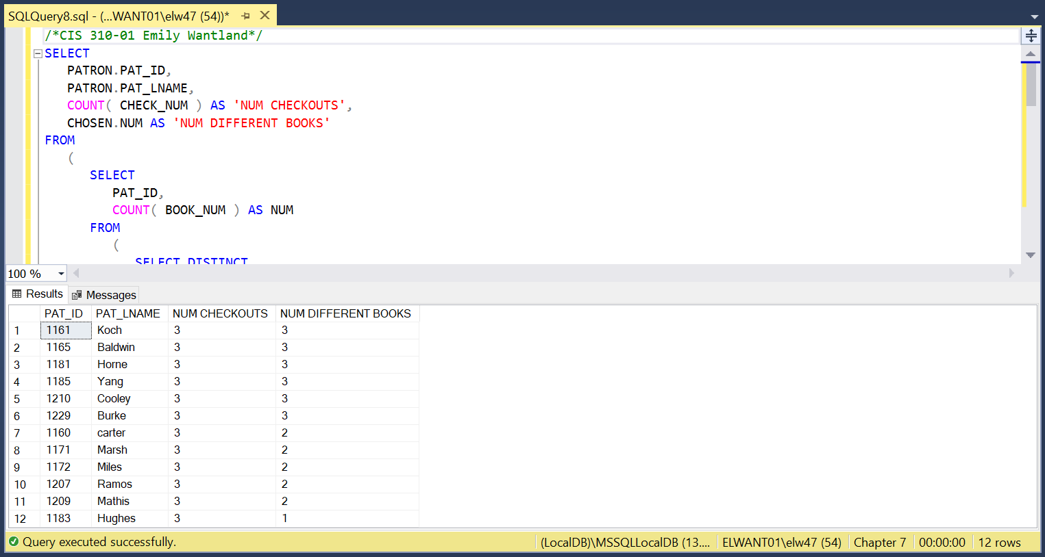

**103.**

/*CIS 310-01 Emily Wantland*/

SELECT

ROUND( AVG( DATEDIFF(Day, CHECKOUT.CHECK_OUT_DATE, CHECKOUT.CHECK_IN_DATE ) ), 2 ) AS 'Average Days Kept'

FROM

CHECKOUT;

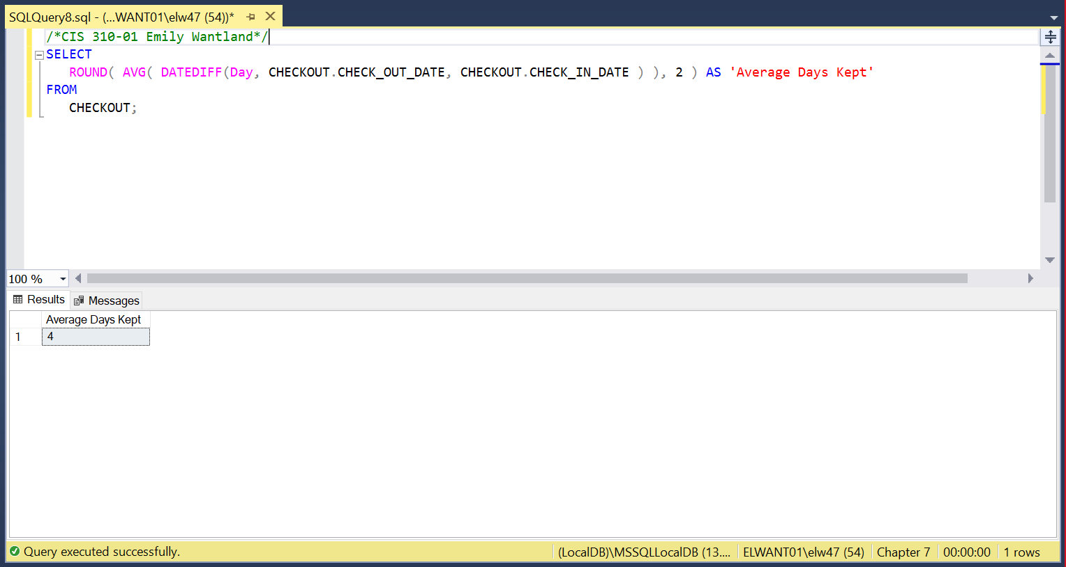

**104.**

/*CIS 310-01 Emily Wantland*/

SELECT

CHECKOUT.PAT_ID,

AVG( DATEDIFF(Day, CHECKOUT.CHECK_OUT_DATE, CHECKOUT.CHECK_IN_DATE )) AS 'Average Days Kept'

FROM

CHECKOUT

GROUP BY

CHECKOUT.PAT_ID

HAVING

Count( CHECKOUT.CHECK_NUM ) >= 3

ORDER BY

AVG( DATEDIFF(Day, CHECKOUT.CHECK_OUT_DATE, CHECKOUT.CHECK_IN_DATE )) DESC;

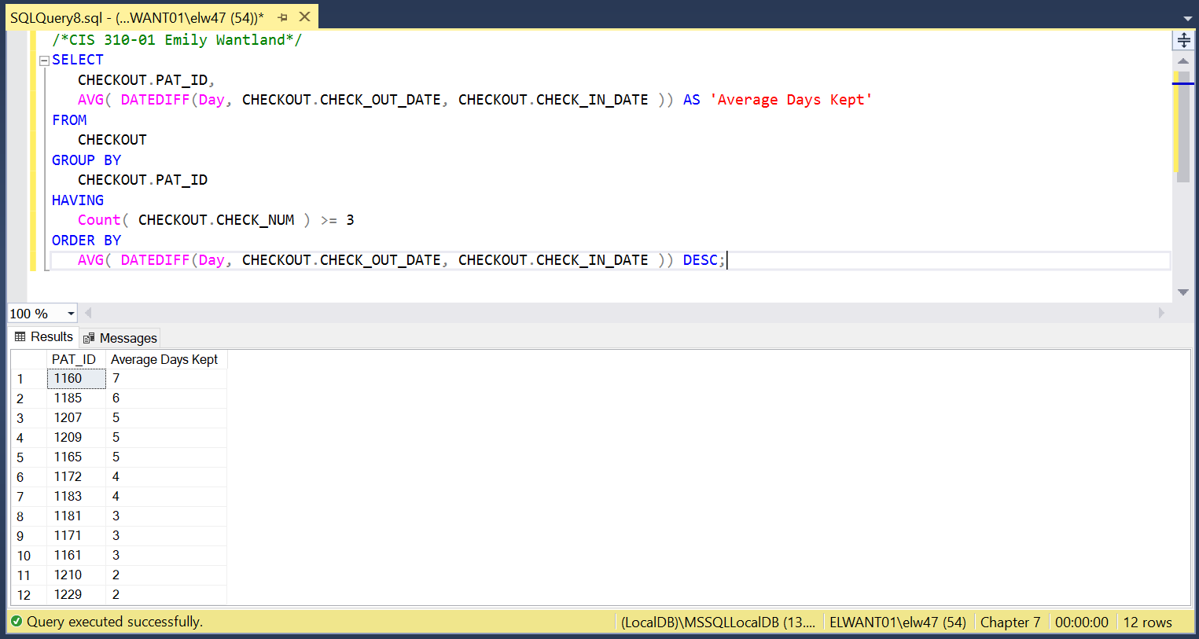

**105.**

/*CIS 310-01 Emily Wantland*/

SELECT

BOOK.BOOK_NUM,

BOOK.BOOK_TITLE,

BOOK.BOOK_COST

FROM

BOOK

WHERE

BOOK.BOOK_COST =

(

SELECT

MIN( BOOK_COST )

FROM

BOOK

)

ORDER BY

BOOK.BOOK_NUM;

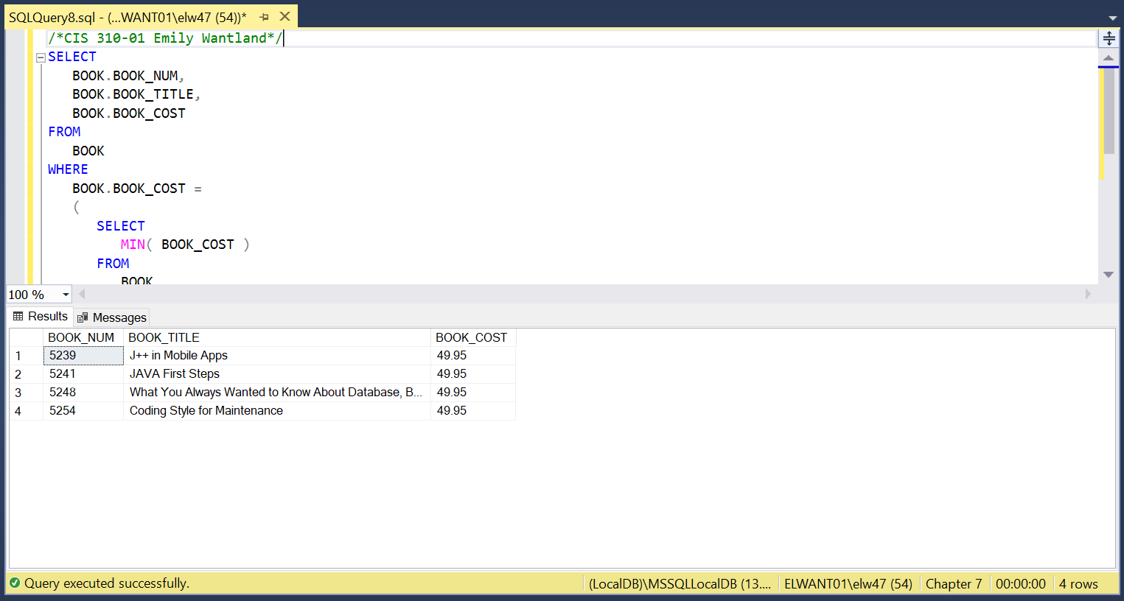

**PART II**

**1.**

/*CIS 310-01 Emily Wantland*/

CREATE TABLE EMP_1 (

EMP_NUM CHAR(3) NOT NULL,

EMP_LNAME VARCHAR(15) NOT NULL,

EMP_FNAME VARCHAR(15) NOT NULL,

EMP_INITIAL CHAR(1),

EMP_HIREDATE DATETIME,

JOB_CODE CHAR(3),

PRIMARY KEY (EMP_NUM)

);

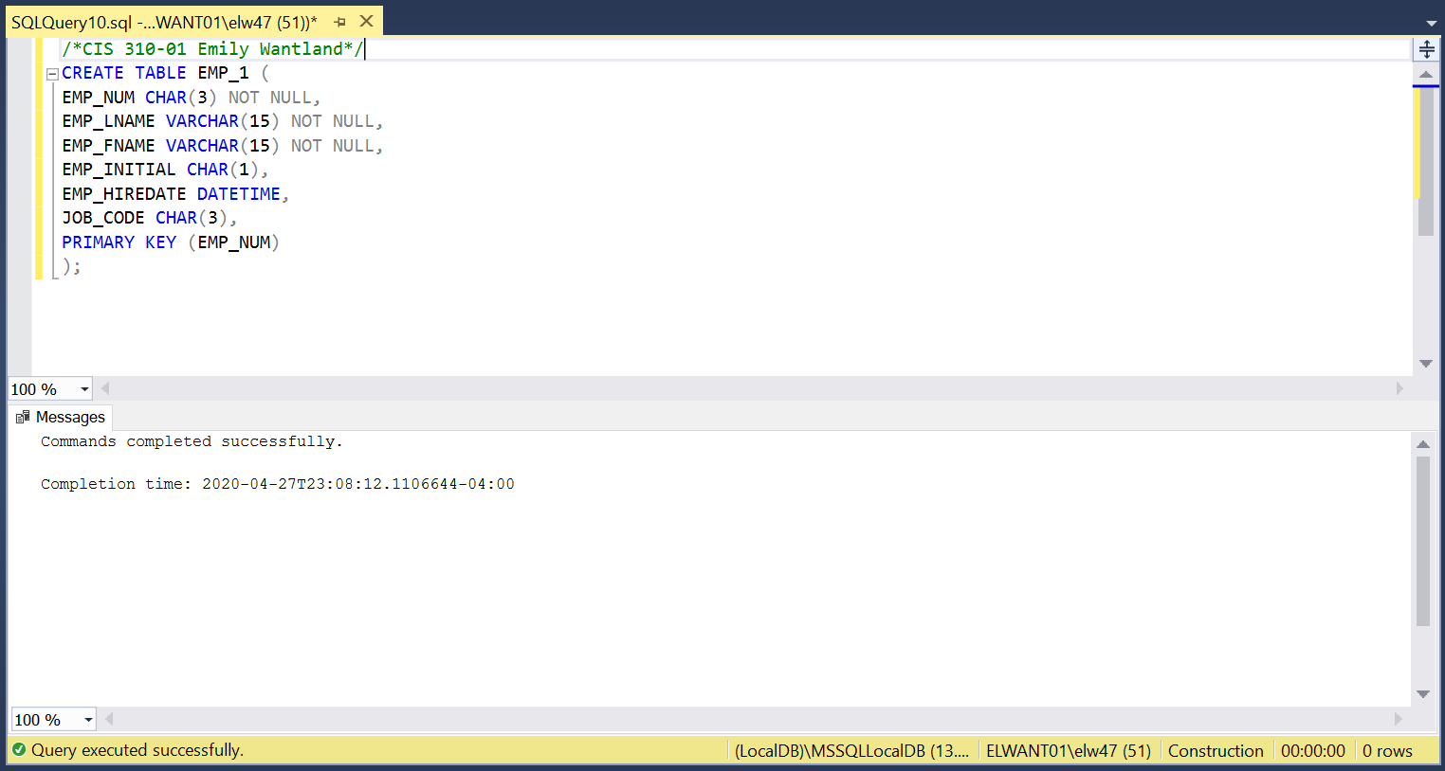

**2.**

/*CIS 310-01 Emily Wantland*/

INSERT INTO EMP_1 (EMP_NUM, EMP_LNAME, EMP_FNAME, EMP_INITIAL, EMP_HIREDATE, JOB_CODE)

VALUES ('101', 'News', 'John', 'G', '2000-11-08 00:00:00', '502');

INSERT INTO EMP_1 (EMP_NUM, EMP_LNAME, EMP_FNAME, EMP_INITIAL, EMP_HIREDATE, JOB_CODE)

VALUES ('102', 'Senior', 'David', 'H', '1989-07-12 00:00:00', '501');

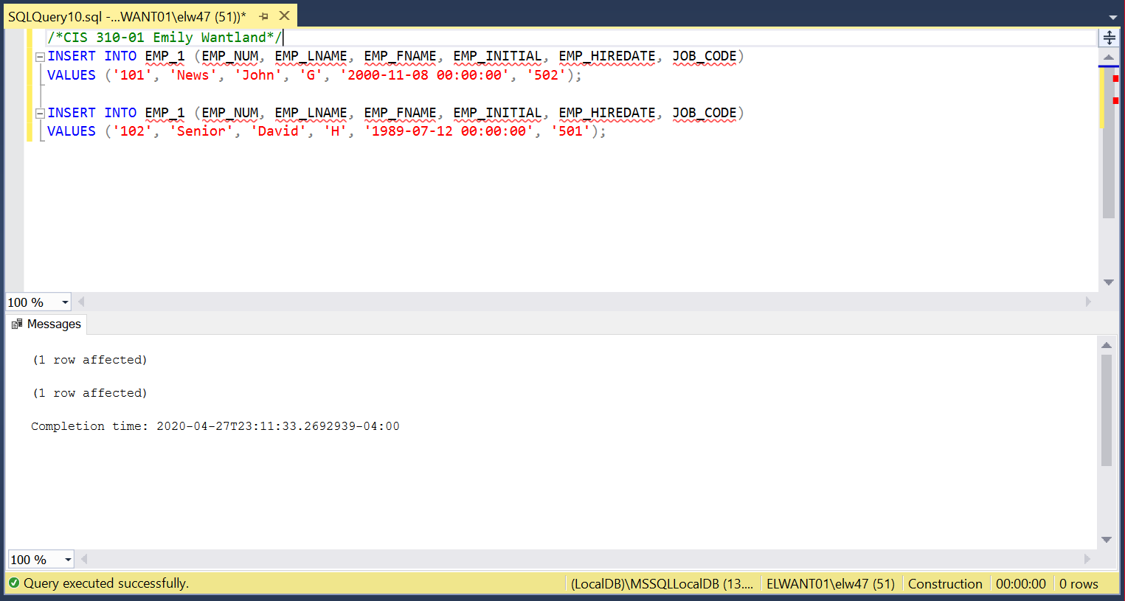

**4.**

/*CIS 310-01 Emily Wantland*/

BEGIN TRAN

COMMIT;

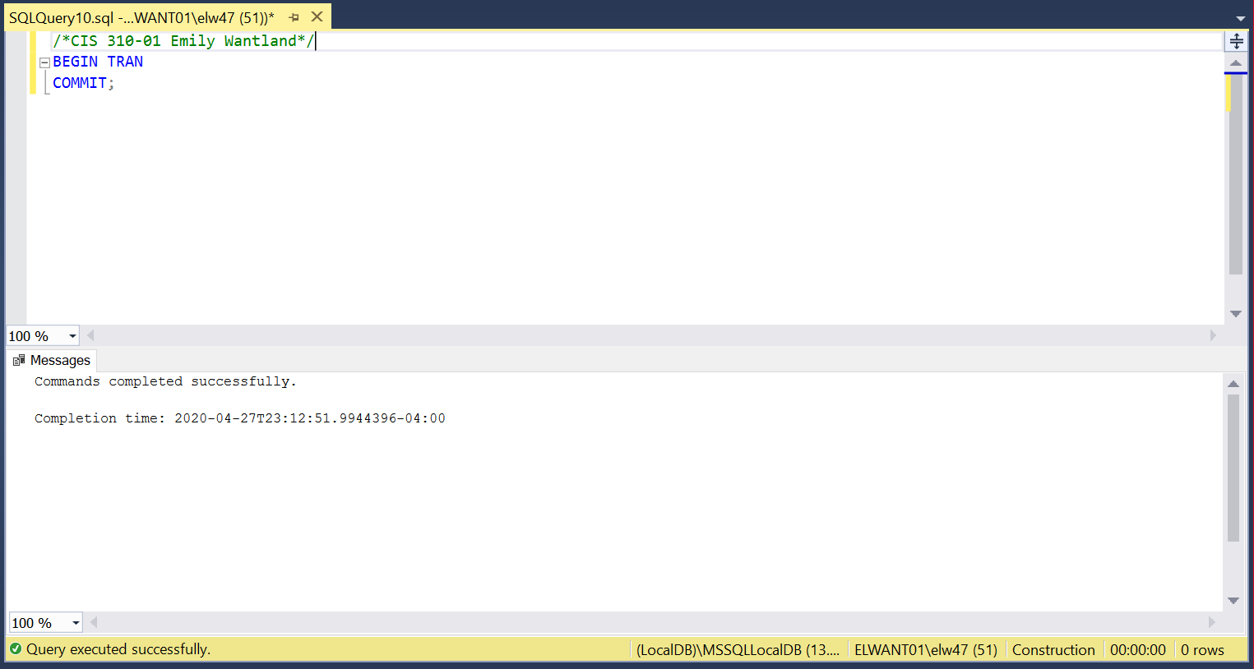

**5**.

/*CIS 310-01 Emily Wantland*/

UPDATE

EMP_1

SET

JOB_CODE = '501'

WHERE

EMP_NUM = '107';

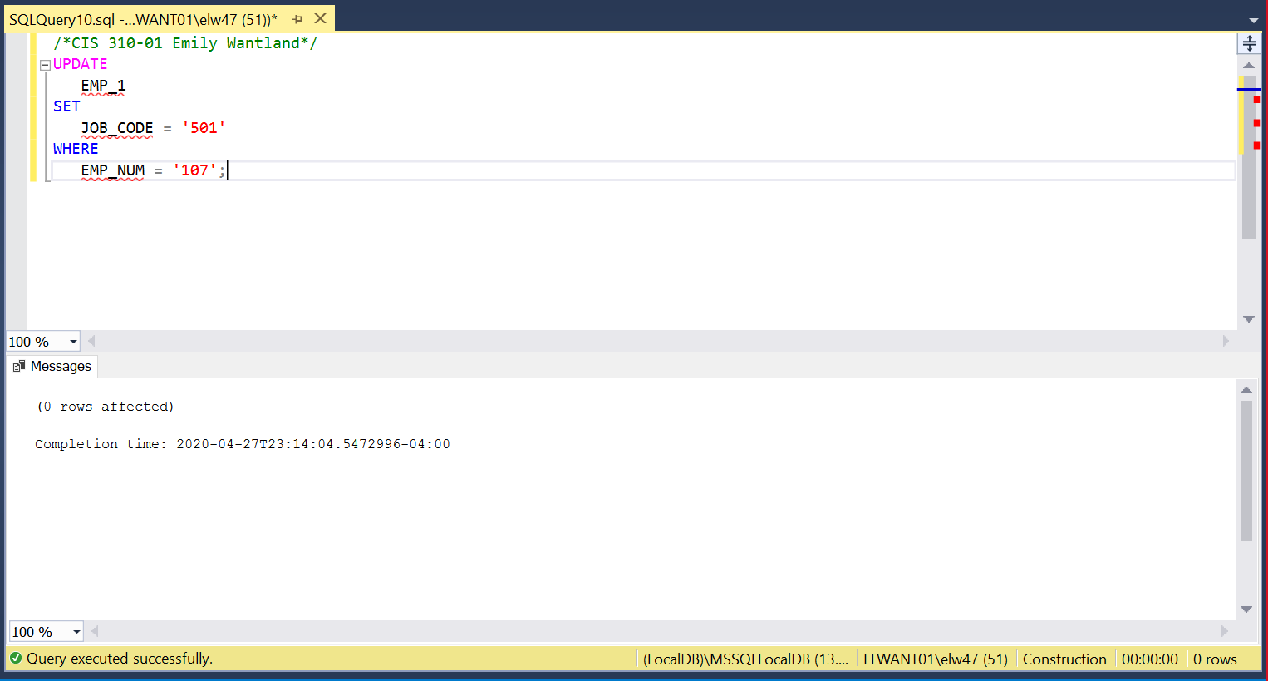

**6.**

/*CIS 310-01 Emily Wantland*/

DELETE

FROM

EMP_1

WHERE

EMP_LNAME = 'Smithfield'

AND EMP_FNAME = 'William';

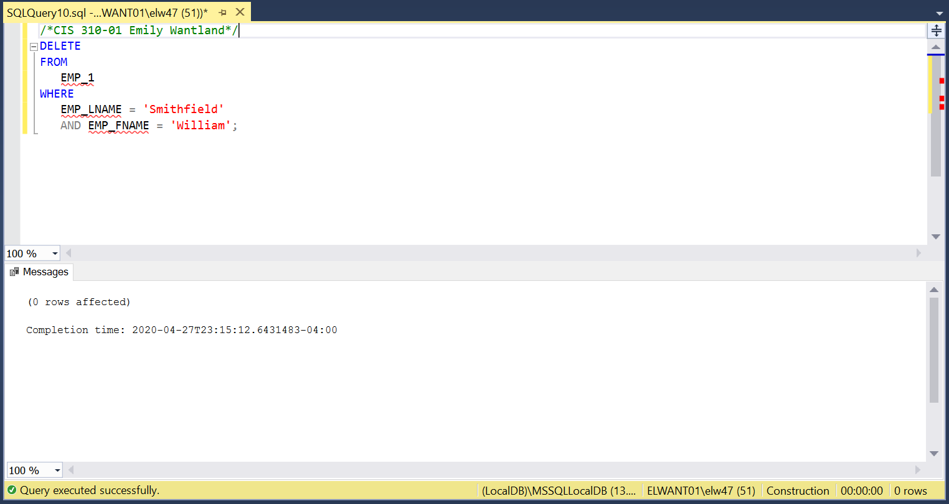

**7.**

/*CIS 310-01 Emily Wantland*/

CREATE TABLE EMP_2 (

EMP_NUM CHAR(3) NOT NULL,

EMP_LNAME VARCHAR(15) NOT NULL,

EMP_FNAME VARCHAR(15) NOT NULL,

EMP_INITIAL CHAR(1),

EMP_HIREDATE DATETIME,

JOB_CODE CHAR(3),

PRIMARY KEY (EMP_NUM)

);

INSERT INTO EMP_2

SELECT * FROM EMP_1;

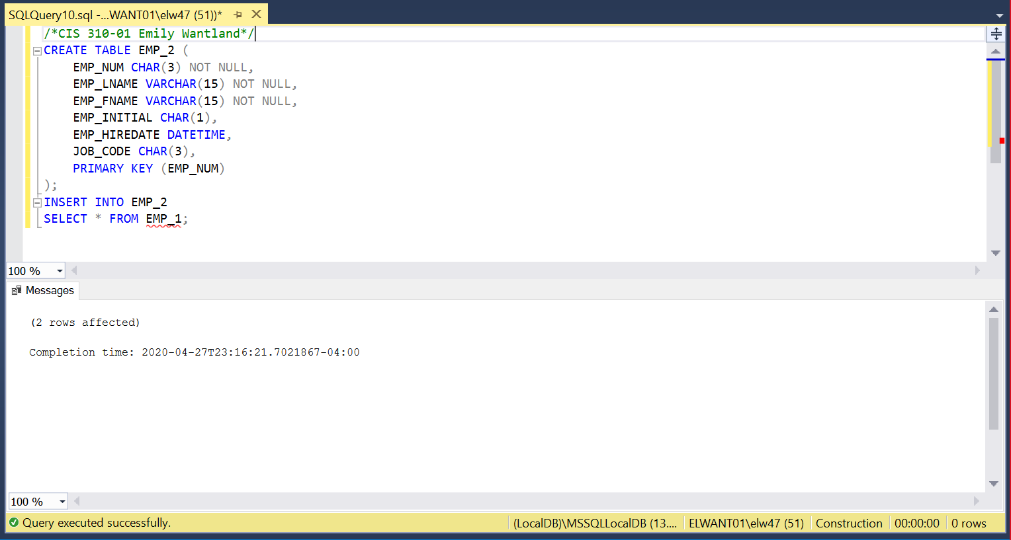

**8.**

/*CIS 310-01 Emily Wantland*/

ALTER TABLE EMP_2

ADD EMP_PCT DECIMAL ( 4, 2 ),

PROJ_NUM CHAR ( 3 ) ;

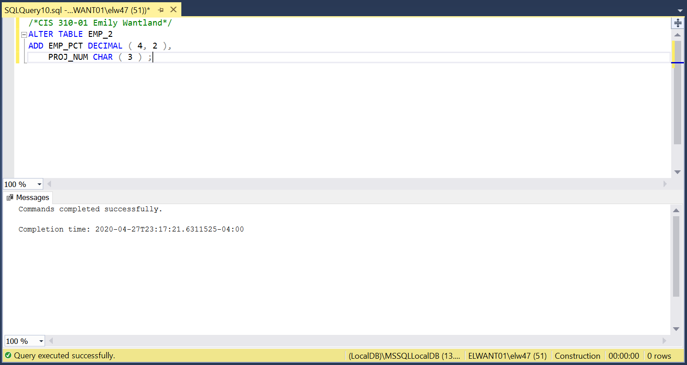

**9.**

/*CIS 310-01 Emily Wantland*/

UPDATE

EMP_2

SET

EMP_PCT = '3.85'

WHERE

EMP_NUM = '103';

